Career Occupation* (if applicable)

Admission Requirements*
Technical Designer, Pattern Grader, Pattern Maker, Jr Pattern Maker, Gerber technician

- High School Diploma or equivalent, or mature student status (19+ on the first day of study)
- Admissions interview: In person or via Zoom/ Skype with the Director of Operations & Admissions or Dean of Studies
- Application Essay: The application essay must clearly describe why you have chosen the Cut Fashion Design Academy. Why you chose this particular program. Why are you passionate about the fashion industry, and what are your future career goals in a minimum of 250 words.
- All applicants must be able to read, write, and communicate in the English language. See language proficiency requirements

Learning Objectives* Upon completion of this program the successful student will
have reliably demonstrated the ability to:

  - Develop Models to industry standards
  - Create Pieces
  - Understand and compose grade rule
  - Be able to Convert data
  - Create Cost Chart and Measure Chart
  - Formulate Technical specification sheets
  - Learn how to use the plotter

Method(s) of Evaluation* The course is broken up into small projects that ultimately come
together to make a cohesive visual understanding of Gerber Pattern Making and Grading. Presentation format and style is determined by each student. Students will receive informal instructor feedback and written evaluations on a regular basis and at least once before 30% of the hours of instruction of the program have been provided.

Completion Requirements* The Cut Academy will use the following grade scale to determine
each student's grade through their work.

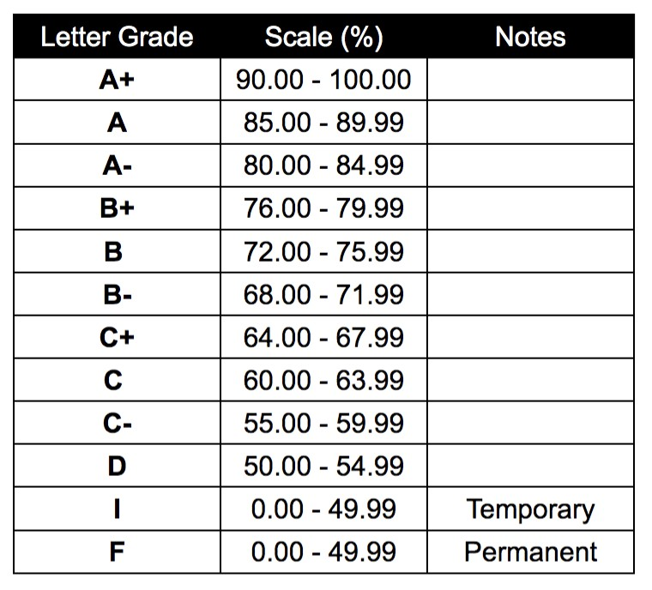
Students must receive an average of 75% from all the assignments in order to pass the course.
In-Class + Homework Assignments X 9 total = 20% Block + Grading Assignments X 9 total = 30% Project 1 - Skirt - 5%
Project 2 - Lined Dress - 10% Project 3 - Student Choice - 10% Project 4 - Jacket - 10%
Replica book - 5% Professionalism - 5%
Attendance - 5%

Program Organization*
Title of Course/Work Experience Component * | # of Hours*
Gerber Pattern Making and Grading | 280 Hours

Term: 14 weeks x 20/hrs = 280 hours
Weekly: Lecture 8 hrs/week. Lab 12 hrs/week

COURSES

INTRODUCTION TO GERBER

- Understand Gerber AccuMark sequence of operations.
- Learn Data Input – How pattern shapes are digitized and entered in the pattern making system.
- Work with Gerber menu items to develop, modify, check and finalize pattern pieces.
- Understand menu, sub-menus and functions to develop pattern making in the system.
- Understand data management, import/export and moving/deleting data.
- Create models to industry standards and run them through the AccuMark processes.

CREATING, SAVING, DIGITIZING & BACKING UP
- Create new pieces through the Create Piece Menu.
- Group existing pieces together and create a new Model File Editor in Pattern Design.
- Determine piece identifications for digitized pieces.
- Create a Grade Rule Table for digitizing purposes.
- Practice Digitizing a Closed Piece and a Mirrored Piece.
- Verify Digitized Data and view pieces in Pattern Design.
- Seam allowance and notches.
- Label a cut line for production
- Be able to edit grade point
- Creating offset line, shortening or lengthen an internal line, creating Drill hole

MANIPULATING BLOCKS

- Create new pieces from drafting
- Create pieces by using the trace function
- Develop dart manipulation
- Get to know all measuring tools
- Rotate and flip pieces and line
- Create straight line, curve line, and flatten line segment
- Assign rule table
- Snap to Geometry
- Trace asymmetrical pieces
- Grading map and rule table data
- Marking orders
- Calculate yield/ efficiency/ block facing/ bump line/ Split/combine marker/ Scale/ Shrinkage
- Remove grading
- Learn how to resize, Mini marker, Export zip, convert data, costing chart and using a measurement chart

PRESENTATION
- Students will create a final project of a digitized tailored jacket
- Students will present their final presentation to peers and the course instructor.

MATERIALS:
$450.00
Drawing Pencil Set Pencil Sharpener Vinyl Eraser Portfolio
Software (Gerber Access)

POTENTIAL GUEST SPEAKERS:
There will be at least 1 guest speaker per semester

BOOKS:
Patternmaking and Grading Using Gerber's AccuMark Pattern Design Software Paperback – Jul 3 2014 y Michele Lininger

$161.00 + TAX

Computer specs needed for Gerber
Recommended

Processor Speed | Intel® Core™ i7 2400 3.1 GHz or higher
System Type | 64-bit OS
Hard Disk Capacity | 230+ GB
Memory | 16 GB
Service Packs | Current
Graphics Card | Open GL Compatible
Student Name:

Student Signature:

