Brief Course Description |  | Introduction to interactive mediums and the fundamentals of the interactive experience. A focus on information architecture, interface design (UI), and user experience (UX). Students will design for digital screens.
Course Prerequisites |  | None
Learning Objectives* |  | Upon completion of this course the successful student will have reliably demonstrated the ability to:  • Recognize effective user interfaces  • Define user goals to inform a design solution  • Organize a body of information based on user experience (UX)  • Create flow charts, wireframes, and visual design mockups using low, mid and high-fidelity prototyping tools  • Apply typography to responsive interactive screens  • Design layouts using using a grid system  • Construct templates and/or pattern libraries  • Analyze visual media within a critical, contextual framework  • Create assets for the web  • Source images ethically  • Demonstrate professional oral and written communication skills
Required course materials* |  | Textbook: Association of Registered Graphic Designers (RGD) Access Ability: A Practical Handbook on Web Design RGD & Government of Ontario  Access to Adobe CC subscription, Macintosh computer
Course Duration |  | 14 weeks, 70 hours total. 3 hr Instructional / 2 hr lab per week.
Homework Hours |  | ~15 hours
Delivery Methods |  | ☐ In-class instruction
Teaching Methods*  Method(s) of Student Evaluation* |  | Lectures, workshops, applied project work, presentations, and field trips
 |  | The course is broken up into small projects that ultimately come together to make a cohesive visual understanding of Web Development. Presentation format and style is determined by each student. Students will receive a written evaluation on a regular basis and at least once before 30% of the hours of instruction of the program have been provided.
Completion Requirements* | The Cut Academy will use the following grade scale to determine each student's grade through their work.  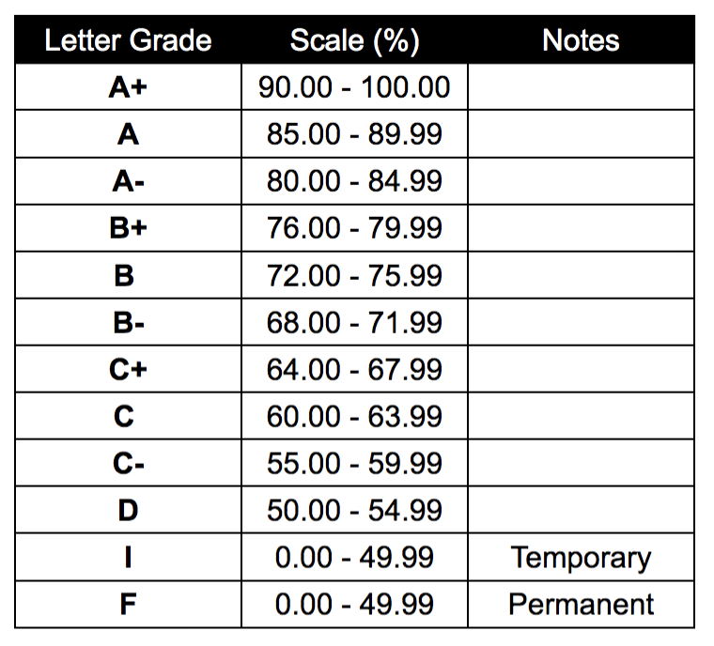  Students must receive an average of 75% from all the assignments in order to pass the course.  Students must receive 50% or above to pass assignments. Assignments will be graded on selected criteria per assignment.

